**Group 1: Dehydrated Greek Yogurt**

**Phase 3 & 4**

**Mass & Energy Balances**

**Barbara McAnulty**

**Rohit Chatterjee**

**Kathryn Atherton**

**Hannah O’Neill**

**November 2018**

**Phase 3: Preliminary Recipe and Mass Balances**

**Gantt Chart**

Although the process is continuous such that all processes are being run simultaneously, this Gantt chart follows one particle throughout the process.

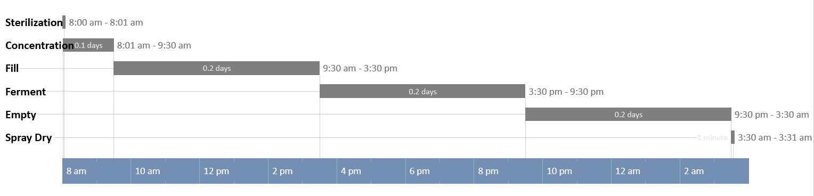

**Process Flow Diagram**

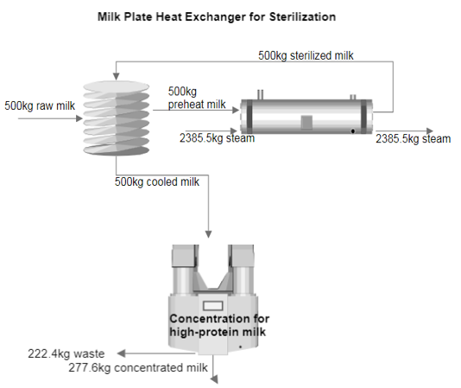



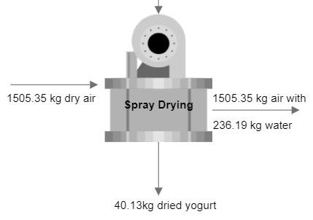

**Overall Plant Mass Balance (for one hour)**

500 kg raw milk + 2385.5 kg steam + 1505.35 kg Dry Air + negligible starter culture + 939 kg chilled water→ 2385.5 kg steam +222.4 kg Concentration Waste +40.13 kg Dried Yogurt + 1741.54 kg Humid Air +939 kg water

**Processing Steps with Mass Balances**

1. **Sterilization**

Regenerative Heating

Methods: A regenerative process is used where the heat treated milk is used to preheat the raw milk input, and the raw milk is used to cool down the pasteurized milk. In this way, the heat can be recycled saving in energy costs. A positive displacement pump is also placed after the plate heat exchanger so that there is higher pressure on the product stream, so if there is a leak, the product will leak into the raw stream. The sterilized milk is also cooled, so that proteins are not denatured (Bylund, 1995).

Mass Balance:

Mass of raw milk + Mass of sterilized milk -> Mass of preheat milk + Mass of cooled milk

500 kg raw milk + 500 kg sterilized milk -> 500 kg preheat milk + 500 kg cooled milk

Temperature: 50 C

Time: 1 minute

Ingredients: 500 kg raw milk

Pasteurization

Methods: The milk is heat treated to remove harmful pathogens and removal of microorganisms that can spoil the taste and shorten the shelf life of milk products (Bylund, 1995). High temperature short time (HTST) pasteurization is used in a plate heat exchanger to heat the milk to 80 C. This is a continuous process that heats up the milk rapidly and keeps it in a holding tube for a residence time of at least 15 seconds to effectively destroy the pathogens (Aguiar, 2014).

Mass Balance:

Mass of preheat milk + Mass of steam -> Mass of sterilized milk + Mass of steam

500 kg preheat milk + 2358.5 kg of steam -> 500 kg sterilized milk + 2358.5 kg of steam

Temperature: 80 C

Time: 1 minute

Ingredients: 500 kg preheat milk

1. **Concentration**

Methods: The sterilized milk passes passes through a microfiltration system to concentrate the stream and remove water and whey protein from the solution. This step increases the density and casein protein content of the final product. Microfiltration pores range from 0.1-10 uM, meaning water, salts, lactose, and whey protein pass through the membrane, while the large casein proteins remain within the retentate stream. The spiral bound cross flow microfiltration system removes 65+% of whey protein and water from the concentrated milk stream. Additional filtration steps could be used to further reduce the final whey percent, however, this filtration step also removes lactose from the concentrated milk stream. Lactose is required for the subsequent fermentation step, so the concentration step is limited to ensure adequate lactose remains in the stream. This industrial microfiltration system is upright and powered by a small pressure differential and a centrifugal pump with a fluid velocity of 0.6 meters per second.

Temperature: 50C

Time: approximately 90 minutes (4 hour absolute max to maintain protein stability)

Ingredients: Sterilized Milk

Mass Balance:

Mass of Sterilized milk -> Mass of Concentrated Milk + Waste

500 kg Sterilized Milk -> 277.6 kg Concentrated Milk + 222.4 kg Waste

*Further Breakdown into Mixture Components*

435 kg water + 65 kg SNF -> (239 kg water + 38.6 SNF) + (196 kg water + 26.4 kg SNF)

Incoming SNF: 33.9 kg lactose + 20.3 kg casein + 4.9 kg whey + 0.7 kg fat + 5.2 kg ash

Outgoing SNF (milk): 10.8 kg lactose + 20.3 kg casein + 1.6 kg whey + 0.7 kg fat + 5.2 kg ash

Outgoing SNF (waste): 23.1 kg lactose + 3.3 kg whey

1. **Fermentation**

Method: Yogurt is fermented with lactic acid bacteria *Lactobacillus bulgaricus* and *Streptococcus thermophilus* in a symbiotic relationship (Bautistia *et. al* 1966). The fermentation occurs at 40C until a pH of 4.2 is reached, which takes about 6 hours, to ensure all proteins have coagulated at or below their isoelectric point of pH ~4.6. Lactose from milk breaks into glucose and galactose. In a 1:2 mole ratio, glucose becomes lactic acid.

This process includes three fermentation tanks such that at any given time, one is fermenting, one is filling with milk, and one is emptying yogurt to the spray dryer. The thin layer of material stuck to the sides of the stainless steel fermentation tank is considered negligible. A sweep CIP occurs at the end of emptying. Because this process begins with an input of 500kg/h of milk, the tanks are 3500L of which just over 3000L will be occupied by the fermenting yogurt. The headspace leaves room for extra meterial if one tank needs to fill beyond 6 hours if the fermenting tank has not reached pH 4.2 in 6 hours (assuming it does so before 7 hours). The tank is not stirred.

From the concentration step, the milk is run through a countercurrent shell-and-tube heat exchanger where the milk becomes 40C and the cooled water, originally 10C, becomes 40C. That water is fed into the water jacket of the filling tank in order to roughly maintain the 40C fermentation setpoint temperature. Water from the sterilization step at 44C is fed into the jacket of the fermenting tank such that the yogurt will maintain within 10% of the setpoint of 40C.

Temperature:

* Inlet fermentation water jacket (from sterilization step): 44C
* Inlet yogurt: 50C
* Inlet chilled water: 10C
* SuperPro inlet chilled water: 5C
* Outlet chilled water/inlet water jacket: 40C
* SuperPro outlet chilled water: 10C
* Fermenting yogurt: 40C
* Outlet yogurt: 15C

Time: 6h fermentation

Ingredients: Concentrated milk, starter culture

Mass Balance:

277.6 kg Concentrated Milk + 939 kg chilled water + negligible starter culture + 8kg extra lactose → 277.6 kg Fermented Yogurt + 939kg water

Within concentrated milk if reaction is assumed to go to completion:

10.8 kg lactose → 5.7 kg glucose → 5.7 kg lactic acid

With extra lactose if reaction is assumed to go to completion:

18.8 kg lactose → 9.9 kg glucose → 9.9 kg lactic acid

References:

Bautista, E. S., Dahiya, R. S., & Speck, M. L. (1966). Identification of compounds causing symbiotic growth of Streptococcus thermophilus and Lactobacillus bulgaricus in milk*. *Journal of Dairy Research, 33*(03), 299. doi:10.1017/s0022029900011985.

1. **Drying**

Temperature:

* Inlet Air: 171 °C
* Feed Inlet: 15 °C

Time: continuous process over one hour

Ingredients: Yogurt, Dry Air

Mass Balance:

Mass of Fermented Yogurt + Dry Air -> Mass of Dried Yogurt + Humid Air

277.6 kg Fermented Yogurt + 1505.35 kg Dry Air -> 40.13 kg Dried Yogurt + 1741.54 kg Humid Air

*Further Breakdown into Mixture Components*

(239 kg water + 5.7 kg lactic acid + 5.7 kg galactose + 20.3 kg casein + 1.6 kg whey + 0.7 kg fat + 5.2 kg ash) + 1505.35 kg air -> (2.81 kg water + 5.7 kg lactic acid + 5.1 kg galactose + 20.3 kg casein + 1.6 kg whey + 0.7 kg fat + 5.2 kg ash) + (1505.35 kg air + 236.19 kg water)

**References**

Aguiar, H.F., Gut, J. (2014). Continuous HTST pasteurization of liquid foods with plate heat exchangers:

Mathematical modeling and experimental validation using a timetemperature integrator. Journal of Food Engineering, 123(1), 78-86.

Burrington, K.J. Milk Fractionation Technology and Emerging Milk Protein Opportunities. *Dairy*

*Research Institute-Technical Report.*

Bylund, G. (1995). Dairy Processing Handbook. Lund, Sweden: Tetra Pak.

Glover, F.A. (1984). Principles of Ultrafiltration and the Concentration and Fractionation of Cow’s

Milk. *Human Milk Banking, Nestle.* 1-16.

Koc, B., Yilmazer, M.S., Balkir, P., Ertekin, F.K. (2010). Spray Drying of Yogurt: Optimization of

Process Conditions for Improving Viability and Other Quality Attributes. *Drying Technology: An International Journal.* **28**(4), 495-507.

**Phase 4: Preliminary Energy Balances**

**Processing Steps with Energy Balances**

**1. Sterilization**

Regenerative Heating Energy Balance:

Energy in raw milk + Energy in sterilized milk = Energy out preheat milk + Energy out cooled milk

(Energy in raw milk - Energy out preheat milk) = (Energy out preheat milk - Energy in sterilized milk)

Change in energy of milk = Change in energy of milk

mmilk * cp,milk * dTmilk,raw = mmilk * cp,milk * dTmilk,sterilized

**Tmilk,preheat = 34 C** (assuming sterilized milk leaves at 50 C)

mfrmilk * cp,milk * dTavg = U * AHX * dTsterilized,milk

**AHX = 0.00315 m2** (U = 267 W/m2K)

Pasteurization Energy Balance:

Energy in sterilized milk + Energy in cold water = Energy out wam milk + Energy out cold water

(Energy in sterilized milk - Energy out warm milk) = (Energy out cold water - Energy in cold water)

Change in energy of milk = -Change in energy of water

mmilk * cp,milk * dTmilk = msteam * cp,steam * dTsteam

**mfrsteam = 39.3 kg/s** (assuming 1 minute to heat milk from 34C to 80C)

mfrsteam * cp,steam * dTavg = U * AHX * dTsteam

**AHX  = 1.85 m2** (U = 267 W/m2K)

**2. Concentration**

Energy Balance:

The major energy expenditures for the filtration system are the pressure differential and height difference of the upright system. The system will be powered by a centrifugal pump.

﻿∆Potential Energy + ∆Enthalpy = Shaft Work

$\underline{m}* g* h +ΔP*A{}_{membrane}*v = \underline{W{}_{s,on}}$

**Ws,on = 30,000kJ total** (Energy requirement for the pump powering membrane filtration system)

h = 2.5 m

∆P = 50,000 Pa (0.5 bar, which is normal for a microfiltration pressure differential)

**Amembrane = 100 m2**

*References:*

Merin, U and Daufin, G. (1990). Crossflow microfiltration in the dairy industry: state-of-the-art. *Lait* 70, 281-291.

(2018). New and Replacement Filters for Microfiltration Systems. *Porex Filtration Group*.

**3. Fermentation**

Energy balance for countercurrent cooling to 40C

Milk at 50C + water at 10C → Milk at 40C + water at 40C

$m_{milk}C_{p,m}ΔT_{m}=m_{water}C_{p,w}ΔT_{w}$

277.6 kg/h * 3.93 kJ/kgK * (50-40)= mwater kg/h *4.1855 kJ/kgK *(40-10)

mwater = 86.9 kg/h

$m_{water}C_{p,w}ΔT_{w} = UAΔT_{ln} =$ 10909.7 KJ/h = 3030.5 J/s

$ΔT_{ln}$ = 10 - 30 / ln(⅓)

where U is ~1700 W/m2K from Geankoplis pg 300, A = 0.098 m2

Super Pro energy balance for countercurrent cooling to 40C

Milk at 50C + water at 5C → Milk at 40C + water at 10C

$m_{milk}C_{p,m}ΔT_{m}=m_{water}C_{p,w}ΔT_{w}$

277.6 kg/h * 3.93 kJ/kgK * (50-40)= mwater kg/h *4.1855 kJ/kgK *(10-5)

mwater = 521.3 kg/h

$m_{water}C_{p,w}ΔT_{w} = UAΔT_{ln} =$ 10909.7 KJ/h = 3030.5 J/s

$ΔT_{ln}$ = 40 - 35 / ln(40/35)

where U is ~1700 W/m2K from Geankoplis pg 300, A = 0.048 m2

Energy Balance for filling and fermenting tank for 6 hours:

Inside the fermentation tank, no heat loss to the environment is assumed since Heisler charts show for any Biot number that the Fourier number would have to be quite large to experience any significant drop in temperature. Even in 6 hours, the Fourier number, dimensionless time, is 0.0108, which is not large enough for any significant temperature drop. Additionally, the filling tank has a steady flow of 40C water to insulate from the surrounding ambient air.

Milk at 40C + negligible heat from bacterial respiration → Yogurt at 40C

Energy Balance for emptying tank for 6 hours:

No running water jacket, so material can begin to equilibrate with ambient air.

Energy balance for countercurrent cooling to 15C

Yogurt at 40C + water at 10C → Yogurt 15C + water at 25C

$m_{yogurt}C_{p,y}ΔT_{y}=m_{water}C_{p,w}ΔT_{w}$

277.6 kg/h * 3.93 kJ/kgK * (40-15)= mwater kg/h *4.1855 kJ/kgK *(25-10)

mwater = 434.4 kg/h

$m_{water}C_{p,w}ΔT_{w} = UAΔT_{ln} =$ 27274.2 KJ/h = 7576.1 J/s

$ΔT_{ln}$ = 15 - 5 / ln(15/5) = 9.1

where U is ~1600 W/m2K from Geankoplis pg 300, A = 1.87 m2

Super Pro energy balance for countercurrent cooling to 15C

Yogurt at 40C + water at 5C → Yogurt 15C + water at 10C

$m_{yogurt}C_{p,y}ΔT_{y}=m_{water}C_{p,w}ΔT_{w}$

277.6 kg/h * 3.93 kJ/kgK * (40-15)= mwater kg/h *4.1855 kJ/kgK *(10-5)

mwater = 1303.2 kg/h

$m_{water}C_{p,w}ΔT_{w} = UAΔT_{ln} =$ 27274.2 KJ/h = 7576.1 J/s

$ΔT_{ln}$ = 30 - 10 / ln(3) = 18.2

where U is ~1600 W/m2K from Geankoplis pg 300, A = 0.937 m2

**4. Drying**

Mass Balance:

Energy of Fermented Yogurt + Energy of Dry Air -> Energy of Dried Yogurt + Energy Humid Air

Delta Energy of Yogurt = - Delta Energy of Air

Delta Energy of Air = Delta Energy due to Temperature Change

* Temperature of Air In = 171C
* Temperature of Air Out = 60.5C
* Mass of air = 1505.35 kg air
* Cp of air = 1.013 kJ/kg.K

1505.35 kg * 1.013 kJ/kg.K * (60.5C - 171C)

= 1505.35 kg * 1.013 kJ/kg.K * -110.5 K

= 1505.35 kg * -111.9365 kJ/kg

= -168503.61 kJ

Delta Energy of Yogurt = Delta Energy due to Temperature Change - Delta Energy due to Water Vaporization

* Temperature of Yogurt + Water In = 15C
* Mass of Water Vaporized = 236.19 kg
* Heat of Vaporization of Water = 581 kJ/kg
* Temperature of Water Out = 60.5C
* Cp of Steam = 1.8644 kJ/kg*K
* Mass of Yogurt + Water Left Over = 40.13 kg
* Cp of Yogurt + Water Left Over = [see Choi-Okos Equation below]
  + Water = 4.1855 kJ/kg.K * 2.81 kg water = 11.76 kJ / K
  + Proteins = (2.0082 × 103 + 1.2089(15) – 1.3129 × 10-3(15)2 J / kg.K) * (21.9 kg) = (2008.2 + 18.1335 - 0.2954) * 21.9 = 2026.04 * 21.9 = 44370.23 J/K = 44.37 kJ/K
  + Fats = (1.9842 × 103 + 1.4733(15) – 4.8008 × 10-3(15)2 J/kg.K) * (0.7 kg) = (1984.2 + 22.1 - 1.08) * 0.7 = 2005.22 * 0.7 = 140.37 J/K = 0.140 kJ/K
  + Carbohydrates = (1.5488 × 103 + 1.9625(15) – 5.9399 × 10-3(15)2 J/kg.K) * (10.8 kg) = (1548.8 + 29.44 - 1.34) * 10.8 = 1576.9 * 10.8 = 17030 J/K = 17.03 kJ/K
  + Ash = (1.0926 × 103 + 1.8896(15) – 3.6817 × 10-3(15)2 J/kg.K) * 5.2 kg = (1092.6 + 28.34 - 0.828) * 5.2 = 1120 * 5.2 = 5824 J/K = 5.824 kJ/K
  + Total = 11.76 kJ / K + 44.37 kJ/K + 0.140 kJ/K + 17.03 kJ/K + 5.824 kJ/K = 79.124 kJ/K

168503.61 kJ = (236.19 kg * 581 kJ/kg) + (236.19 kg * 1.8644 kJ/kg*K * (60.5C - 15C)) + (79.124 kJ/K * (Temperature of Yogurt Out - 15C))

168503.61 kJ = 483103 kJ + 33246.43 kJ + (79.124 kJ/K * (Temperature of Yogurt Out - 15C))

168503.61 kJ = 137234.67 kJ + 33246.43 kJ + (79.124 kJ/K * (Temperature of Yogurt Out - 15C))

Temperature of Yogurt Out = 40C

**References**

Geankoplis, C.J. (2003). *Transport Processes and Separation Process Principles*. Upper Saddle River, NJ

Prentice Hall.

Merin, U and Daufin, G. (1990). Crossflow microfiltration in the dairy industry: state-of-the-art. *Lait* 70,

281-291.(2018). New and Replacement Filters for Microfiltration Systems. *Porex Filtration Group*.

**Appendix A: Calculations**

1. **Sterilization**

Regenerative Heating Energy Balance Equation

mmilk * cp,milk * dTmilk,raw = mmilk * cp,milk * dTmilk,sterilized

mmilk = 500 kg

cp,milk = 3.95 kJ/kg/K (Geankoplis, 2003)

Tmilk,raw = 4 C

Tmilk,preheat = ?

dTmilk,raw = 4C - Tmilk,preheat

Tmilk,sterilized = 80 C

Tmilk,cooled = 50 C

dTmilk,sterilized = 50 C - 80 C = -30 C = -30 K

**Tmilk,preheat = 34 C**

mfrmilk = 0.139 kg/s

dTavg = [(Tmilk,cooled - Tmilk,raw) + (Tmilk,sterilized - Tmilk,preheat)]/2

dTavg = [(50 - 4)+(80 - 34)]/2 = 46 K

U = 267 W/m2K (Geankoplis, 2003)

dTsterilized,milk = 80 - 50 = 30 K

**AHX = 0.00315 m2**

Pasteurization Energy Balance

mmilk * cp,milk * dTmilk = msteam * cp,steam * dTsteam

mmilk = 500 kg

cp,milk = 3.95 kJ/kg/K

Tmilk,preheat = 34 C

Tmilk,sterilized = 80 C

dTmilk = 34 - 80 = -46 K

cp,steam = 1.926 (Geankoplis, 2003)

Tsteami = 200 C

Tsteamo = 180 C

dTsteam = 20 K

Solving for msteam

msteam = 2358.5 kg to heat the preheat milk to the sterilized milk temperature

Assuming 1 minute to heat up 500 kg of milk **mfrsteam = 39.3 kg/s**

U = 267 W/m2K (Geankoplis, 2003)

dTavg = [(Tsteamf - Tmilk,preheat) + (Tsteami - Tmilk,sterilized)]/2

dTavg = [(180 - 34) + (200 - 85)]/2 = 130.5 K

dTsteam = 200 - 180 = 20 K

**AHX = 1.85 m2**

**Appendix B: SuperPro Documents and Comparison**

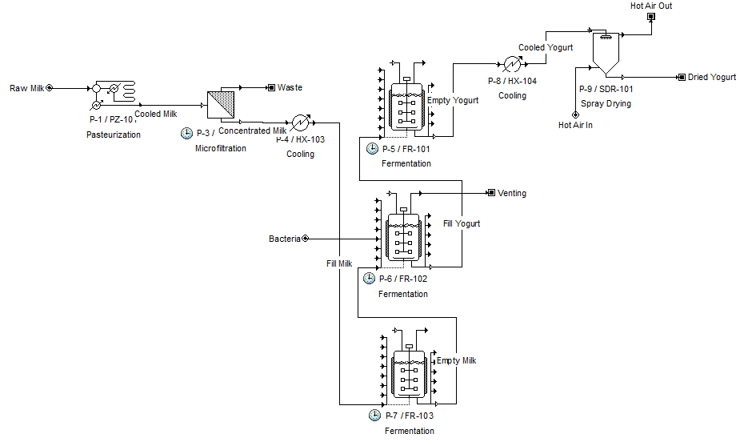

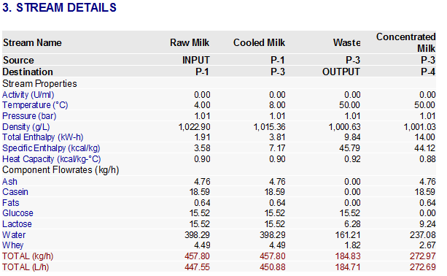

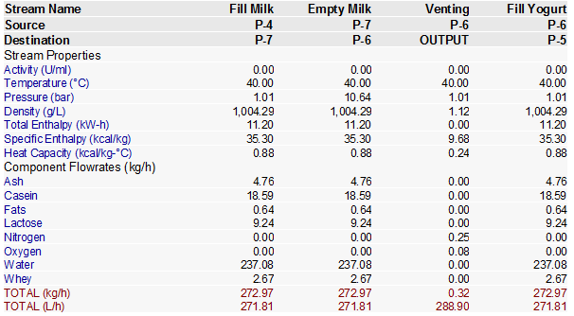

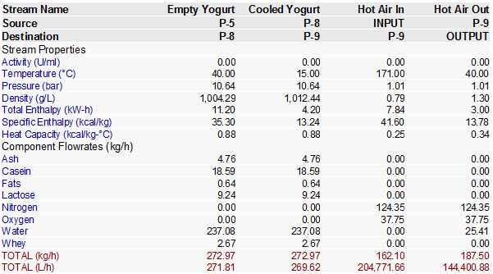

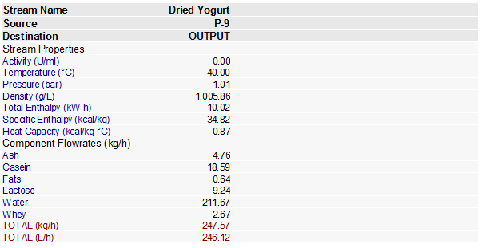

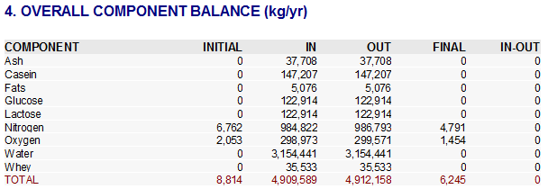

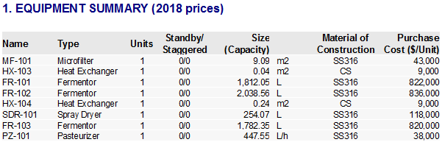

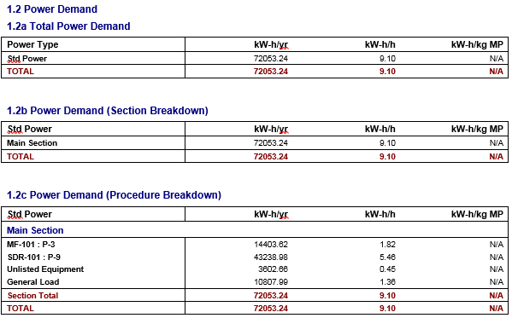

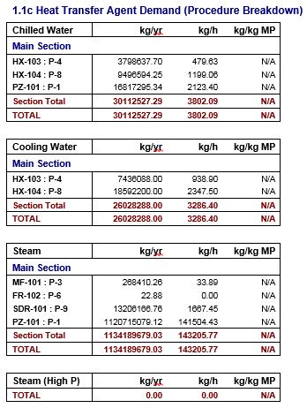

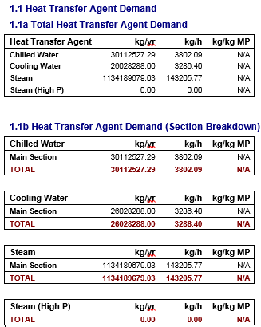

Differences between hand calculations and SuperPro’s mass balance calculations occurred due to restrictions on certain unit operation properties that SuperPro did not allow the user to alter. For example, in the fermentation process, the SuperPro software did not allow inclusion of the intermediate step of breaking glucose into lactose and galactose which altered the mass balance of the operation. Additionally, the hand calculation for energy balance within the concentration unit operation used a mass percent retention method, while SuperPro software required the use of retention coefficients that differed slightly from the previous values. Finally, in order to ensure that the continuous timing worked within the SuperPro software, the program required the auto-adjustment of the input mass flow rates.

Additionally, there were variations between the energy balance calculations determined by hand and via the superpro software. The energy requirements for the individual units were calculated by hand, focusing on equipment cross-sectional area and temperature variations over an hourly time frame. The superpro software compiled energy data as one continuous process, outputting input steam and power information for a large-scale operation with daily and yearly requirements. The software added additional details about the heat transfer input streams, and it restricted user ability to adjust certain temperature requirements within the unit operations. For example, the regeneration temperature of the pasteurization process was not adjustable, and this altered the energy balance for the entire pasteurization process.